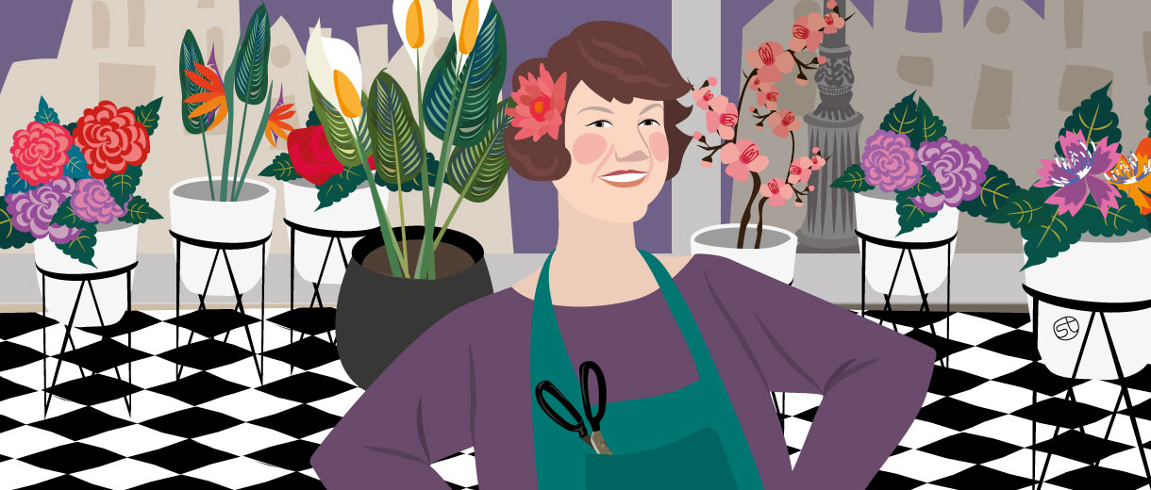

Florist Ursula Stone: “Blooming For Good In My 50s”
- Dec 22, 2019

- Lorenza Bacino

- Crunchy People
4 min read
Her new journey started at her kitchen table at the age of 50. Following redundancy, she signed up for a class at Capel Manor College and re-trained as a florist. Today she runs The Flower Bank, a zero-waste social enterprise that reduces flower and foliage wastage by taking unwanted produce from supermarkets and turning it into beautiful designs for the local community. Working with volunteers and young offenders, the talented florist crafts wonderful re-purposed flower arrangements for old people’s homes, contact centres, local community places and those in need of a bouquet on a budget.
Our senior contributor, Lorenza Bacino has met the lady who is turning her passion into a mission; creating employment and reinvesting their profits back into the business and the local community, running activities in dementia units, mental health recovery programmes & affordable housing for the elderly.
***
Looking at Ursula Stone standing proudly in her new flagship florist*, a cup of tea in hand, discussing the final flourishes to her shop floor with her builders, it’s hard to imagine her as a “disempowered” and “useless” person. Yet for 15 years she’d been trapped in an unhappy marriage and with midlife fast approaching and a difficult divorce behind her, she needed to dig deep and find herself. “I had to stamp my personality onto something after such a long time of putting my needs to one side.”
For the first time in years, she had time alone as she had her daughters on alternate weekends. This is when the idea of personal development took root.
Rather than sitting at home twiddling my thumbs and binging on crisps, I discovered crafts. I had to catch up on those lost years and wanted to use my alone time in the best possible way. I began doing mosaics and realised that creating beautiful things made me feel fantastic.
Ursula had always had an interest in crafts but hadn’t pursued it. Redundancy gave her the impetus to seek new horizons. She started tending the graves of people’s family and friends.
I wanted to leave tributes on them at significant times of year but didn’t know how to do it so I enrolled on a 6-week floristry course at Capel Manor College where I caught the floristry bug. Studying Floristry has shaped the person I have become, given direction to my life, and made me a social entrepreneur.
During her course, she’d been struck during her work experience by the obscene number of flowers that are used for one event and then dumped, whilst still in mint condition. She began salvaging the disused flowers and repurposing them. After much letter-writing, she managed to get local branches of Aldi and Morrisons to agree to her collecting their wasted flowers to make use of them and since then, things have gone from strength to strength.

A community florist and learning centre
Ursula went on to repurpose flowers for weddings and funerals on a budget and currently has a scheme with young offenders between the ages of 11-18 under the Haringey Council. She does workshops with them where she teaches them to make displays out of repurposed flowers, which are then distributed to old people’s homes and other centres. “They love it”, she enthuses. “Working with their hands and enjoying the colours and the smells has a calming effect and often we talk as we work so it’s a kind of therapy for them too.” The young offenders (mostly boys it turns out) obtain a certificate in floristry and gain a sense of pride in their achievements, as do their parents.
One boy said to me he’d never had a certificate for anything before. It moved me so much to see that what I’m doing is having such a positive impact on their self-esteem. That’s what it’s all about for me.
Her idea is now going to be replicated in the borough of Barnet, and her New Barnet florist shop will be the base for the young offenders to come and learn a skill and serve customers too. “I love the whole floristry effect on people, the contact with the colours, the earth and the happiness it gives. It’s contagious.”
Another initiative that gives Ursula great joy is ‘flower bombing’. She leaves bunches of flowers in random places with a message to whoever finds them to take them, enjoy them, and possibly post a picture on Instagram. “People had so much fun with this”, laughs Ursula. “I leave them in some hilarious places and I’ve had so much who finds them.”
Clearly, the benefits of floristry extend far beyond just receiving a bunch of flowers.
I’m going on 53 and have never been happier. All my previous experiences in my 20s have come together to make me who I am today in my 50s – she explains-, like the film ‘Slumdog millionaire’ when the answer to each question relates to an experience in his life. I’m confident and no longer seek other people’s approval – she smiles, looking around her gorgeous new florist shop-. Easing into retirement doesn’t exist , I’ve never worked so hard either, and what I’m doing is all-consuming, but I know I’m right and I know this will work.

*Thanks to crowdfunding that raised almost £70,000, as well as grants and lottery funds, the Flower Bank Hub is being officially opened on Sunday 1st December in New Barnet (London) by the renowned florist, Simon Lynette.

charitycommunityengagementflorist shopflowersgood causesustainability

